Parse.ai
Loan Portfolio Analytics Dashboard
Interview Case Study — Requirements Document
Version 1.0 | Confidential

1. Case Study Briefing

1.1 Background
Parse.ai is a deterministic AI platform purpose-built for lending analytics. We serve Credit, Risk, Collections, and Sales teams at NBFCs and banks, enabling business users to build, validate, and productionise predictive models without writing code.
As part of our hiring process, we ask engineering candidates to complete a structured case study that mirrors the real problems we solve for clients. This exercise is your opportunity to demonstrate how you think about data, architecture, and product.

1.2 What You Are Building
You will design and implement a Loan Portfolio Analytics Dashboard that ingests raw loan tape data and produces a defined set of portfolio metrics and visualisations. The User should also be able to interact and ask any questions about the information presented in the graph. The application must be built using an Agentic Architecture — a system in which one or more AI agents orchestrate the data ingestion, transformation, metric computation, and visualisation steps.
The core challenge is that the input data schema is intentionally undefined. You will receive two loan tapes, each with a different schema. Your system must be capable of understanding the structure of any incoming CSV (or set of CSVs), mapping fields to the canonical data model, and computing the required metrics without manual schema configuration.

1.3 Input Data
You will be provided with two loan tapes in CSV format. Each loan tape contains information spanning the following data domains. The fields, column names, and file structure will differ between the two tapes — your system must handle both.

Data Domains
- Borrower-level information (demographics, identity, KYC attributes)
- Borrower credit history (bureau scores, delinquency history, credit utilisation)
- Loan facility-level data (loan ID, product type, disbursement date, sanctioned amount, interest rate, tenor, maturity date, loan status)
- Payment schedule (expected EMI due dates, EMI amounts, principal and interest components)
- Payment transaction data (actual payment dates, amounts received, principal collected, interest collected, charges collected)
- Collateral-level data (collateral type, value, security interest details)
- Guarantor-level data (guarantor identity, creditworthiness details)

The data across these domains may be provided in a single consolidated file or split across multiple files. Your ingestion agent must discover and reconcile the data regardless of how it is structured.
Note: You are not required to use every field in every domain for this exercise. Focus on the fields needed to compute the 17 metrics defined in Section 3.

1.4 Agentic Architecture Requirement
Your solution must be implemented as an agentic system. The following is the minimum expected architecture. You are free to go beyond this.

- Schema Discovery Agent: Reads the uploaded CSV file(s), infers the schema, identifies relevant columns for each data domain, and maps them to a canonical internal data model.
- Data Validation Agent: Checks for completeness, referential integrity, temporal consistency, and of the ingested data. Surfaces data quality issues clearly.
- Metric Computation Agent: Computes all 17 portfolio metrics defined in Section 3, applying the exact definitions and formulas specified.
- Visualisation Agent: Renders the required charts and tables in the dashboard UI, applying the visualisation guidelines in Section 3. The graphs should include Filters so user can slice and dice all loan portfolio metrics by Product, Region and City.
- Interaction Agent: User can ask any questions about the graph and the data presented and this agent should provide an appropriate analysis.
- Orchestrator: Coordinates the above agents, manages state, handles errors, and routes outputs.

You may implement this using any framework or LLM provider of your choice. The agents must be genuinely agentic — i.e., they must use tools, make decisions, and adapt to the structure of the input data rather than relying on hard-coded schema assumptions.

1.5 Deliverables
- A working application that ingests either of the two provided loan tapes and renders the dashboard.
- Source code in a version-controlled repository (GitHub preferred), with a clear README explaining how to run the application.
- A brief architecture document (1–2 pages or a diagram) describing your agentic design: which agents exist, what tools each agent uses, and how they communicate. Alternatively, you can draw out the architecture in a paper, in a clear and legible manner) and send a screen shot.

1.6 Evaluation Criteria

Criterion | Weight | What We Look For
Agentic Architecture | 25% | Schema-agnostic ingestion agent, clean orchestration, modular tool use
Metric Accuracy | 25% | Correct computation of all 17 metrics, edge cases handled
Visualisation Quality | 20% | Charts match specification, interactivity (filters, time-window selectors) works correctly
Code Quality | 15% | Readable, well-structured, documented, testable
Handling Unknown Schema | 15% | Robustness when given Loan Tape 2 (different schema from Loan Tape 1)

1.7 Constraints and Ground Rules
- You may use any programming language, framework, or cloud service.
- You may use any LLM API (OpenAI, Anthropic, etc.). Budget usage sensibly — efficiency matters.
- All computation must be deterministic and reproducible for the same input data.
- Do not hard-code any schema assumptions that would break if a field is named differently.
- Ask clarifying questions before starting if anything in this document is ambiguous. Do not waste time on incorrect assumptions.

2. Canonical Data Model and Definitions

2.1 DPD Bucket Definitions
Days Past Due (DPD) is calculated as the number of calendar days elapsed since the earliest unpaid instalment was due, as at each month-end snapshot date. All transition matrices and delinquency metrics in this document use the following five standard buckets.

DPD Bucket | Description
Current (0 DPD) | No overdue instalment. Borrower is fully up to date.
DPD 1–30 | Overdue between 1 and 30 days. Special Mention / Standard with watch.
DPD 31–60 | Overdue between 31 and 60 days. Sub-Standard.
DPD 61–90 | Overdue between 61 and 90 days. Sub-Standard / Doubtful.
DPD 90+ | Overdue more than 90 days. Non-Performing Loan (NPL) / Loss.

Note: DPD is always assessed at month-end. A borrower who pays on the last day of the month is treated as Current for that month.

2.2 Principal Outstanding (POS)
Principal Outstanding (POS) refers to the unpaid principal balance of a loan as at a given month-end snapshot date. It excludes accrued interest, fees, and penalties. POS is the primary exposure measure used across most metrics in this document.
Formula: POS = Disbursed Principal − Cumulative Principal Repaid (as at snapshot date)

2.3 Active Loan
A loan is considered Active if it has been disbursed and has not yet been fully repaid, foreclosed, written off, or otherwise closed as at the snapshot date. Loans in any DPD bucket — including 90+ — are Active unless explicitly marked otherwise in the data.

2.4 Cohort
A disbursement cohort is the group of loans whose disbursement date falls within the same calendar month. Cohorts are labelled by their disbursement month (e.g., Apr-2023, May-2023). Month on Book (MOB) is the number of complete calendar months elapsed since disbursement month for each cohort.

2.5 EMI
Equated Monthly Instalment (EMI) is the scheduled periodic payment comprising a principal component and an interest component as per the loan amortisation schedule. Total EMI Due in a given month is the sum of all scheduled instalments due in that month across all active loans in scope.

2.6 Snapshot Date Convention
All portfolio-level metrics are computed at month-end snapshot dates unless stated otherwise. When computing transition matrices or movement-category charts, the start state is the DPD bucket at the prior month-end and the end state is the DPD bucket at the current month-end.

3. Metric Definitions and Visualisation Guidelines

This section defines all 17 required metrics. Each entry includes the metric name, precise definition, formula where applicable, data inputs, and exact visualisation requirements. Candidates must implement each metric exactly as specified. Any deviation must be documented and justified.

Metric 1 Portfolio Summary Table
Description
A tabular summary displaying the five key portfolio-level KPIs as at the latest month-end snapshot date in the dataset.

Metric | Definition | Unit | Aggregation
Principal Outstanding | Sum of unpaid principal balance across all active loans as at the latest month-end snapshot date. | INR (Crore) | Sum
Interest Outstanding | Sum of accrued but uncollected interest across all active loans as at snapshot date. | INR (Crore) | Sum
Number of Active Loans | Count of loans where the loan status is Active (i.e., neither closed, foreclosed, nor written off) as at snapshot date. | Count | Count
Weighted Avg. Interest Rate | Interest rate of each loan weighted by its current Principal Outstanding. Formula: SUM(Rate_i x POS_i) / SUM(POS_i) | % per annum | Weighted mean
Weighted Avg. Tenor | Remaining tenor of each loan weighted by its current Principal Outstanding. Remaining tenor = (Original Maturity Date − Snapshot Date) in months. Formula: SUM(Tenor_i x POS_i) / SUM(POS_i) | Months | Weighted mean

Visualisation Requirements
- Render as a single horizontal summary table or a set of five KPI cards (tile layout).
- Each KPI must display the metric name, the computed value, and the unit of measure.
- If rendered as KPI cards, include a delta indicator showing the month-on-month change (absolute and percentage).
- The snapshot date used for the computation must be displayed prominently above the table.
- Principal Outstanding and Interest Outstanding values should be expressed in INR Crore, rounded to two decimal places.
- Weighted Average Interest Rate should be expressed as a percentage rounded to two decimal places.
- Weighted Average Tenor should be expressed in months rounded to one decimal place.

Metric 2 POS Distribution by DPD Bucket — Latest Month-End
Description
A bar chart showing the distribution of Principal Outstanding (in INR) across the five standard DPD buckets as at the latest month-end snapshot date in the dataset.
Formula
For each DPD bucket b: POS_b = SUM of Principal Outstanding of all active loans whose DPD at month-end falls within bucket b.
Visualisation Requirements
- Chart type: Vertical bar chart.
- X-axis: DPD bucket labels in ascending order of severity (Current, DPD 1–30, DPD 31–60, DPD 61–90, DPD 90+).
- Y-axis: Principal Outstanding in INR Crore.
- Each bar must be labelled with the absolute POS value and the percentage of total portfolio POS.
- The chart title must clearly state the snapshot date.
- Use a diverging colour scheme: Current = green, DPD 1–30 = amber, DPD 31–60 = orange, DPD 61–90 = deep orange, DPD 90+ = red.
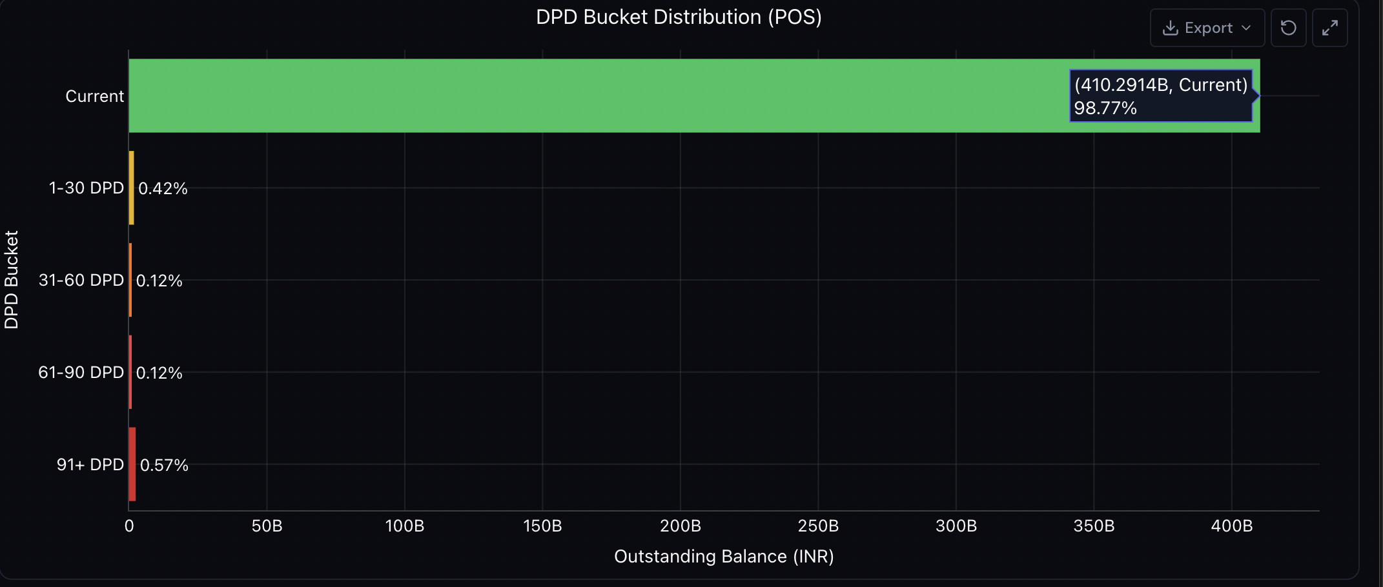
Metric 3 Overall Collections Efficiency — Time Series
Description
A dual-series chart showing Total EMI Due vs. Total Amount Collected over time, for the entire active portfolio. Presented in two views: Monthly and Quarterly.
Definitions
- Total EMI Due (Month): Sum of all scheduled EMI instalments due across all active loans in the calendar month.
- Total Amount Collected (Month): Sum of all actual payments received in the calendar month (principal + interest components only, excluding penalty or bounce charges).
- Collections Efficiency Rate: Total Amount Collected / Total EMI Due, expressed as a percentage.
Visualisation Requirements
- Chart type: Grouped bar chart (one bar per series per period) with a line overlay for the Collections Efficiency Rate (%).
- Two tabs or toggle buttons: Monthly View and Quarterly View.
- In Quarterly View, aggregate EMI Due and Amount Collected by calendar quarter.
- X-axis: Time periods (month labels e.g. Apr-2023 or quarter labels e.g. Q1-FY24).
- Primary Y-axis (left): INR Crore.
- Secondary Y-axis (right): Collections Efficiency Rate (%).
- The efficiency rate line must include data labels at each period.
- Bars: EMI Due = steel blue, Amount Collected = teal green.
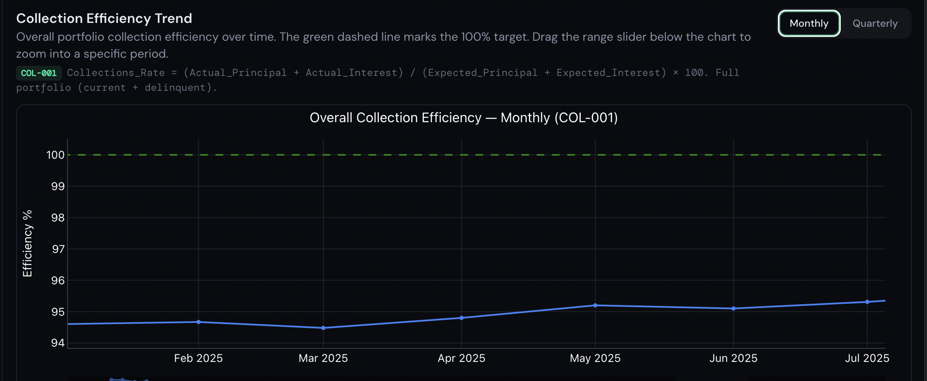
Metric 4 Collections Efficiency by DPD Bucket
Description
A bar chart showing the Collections Efficiency Rate broken down by DPD bucket, for a user-selected month.
Formula
Collections Efficiency Rate (Bucket b, Month m) = SUM(Amount Collected from loans in bucket b in month m) / SUM(EMI Due from loans in bucket b in month m), expressed as a percentage.
Notes
A loan's DPD bucket is determined at the start of the month (prior month-end snapshot) for the purpose of this metric.
Visualisation Requirements
- Chart type: Horizontal bar chart (one bar per DPD bucket).
- A month selector control must be provided to allow the user to choose the reporting month.
- Y-axis: DPD bucket labels.
- X-axis: Collections Efficiency Rate (%).
- Each bar must be labelled with the efficiency rate value.
- Colour scheme: match the DPD severity palette from Metric 2.
- Add a vertical reference line at 100% efficiency.

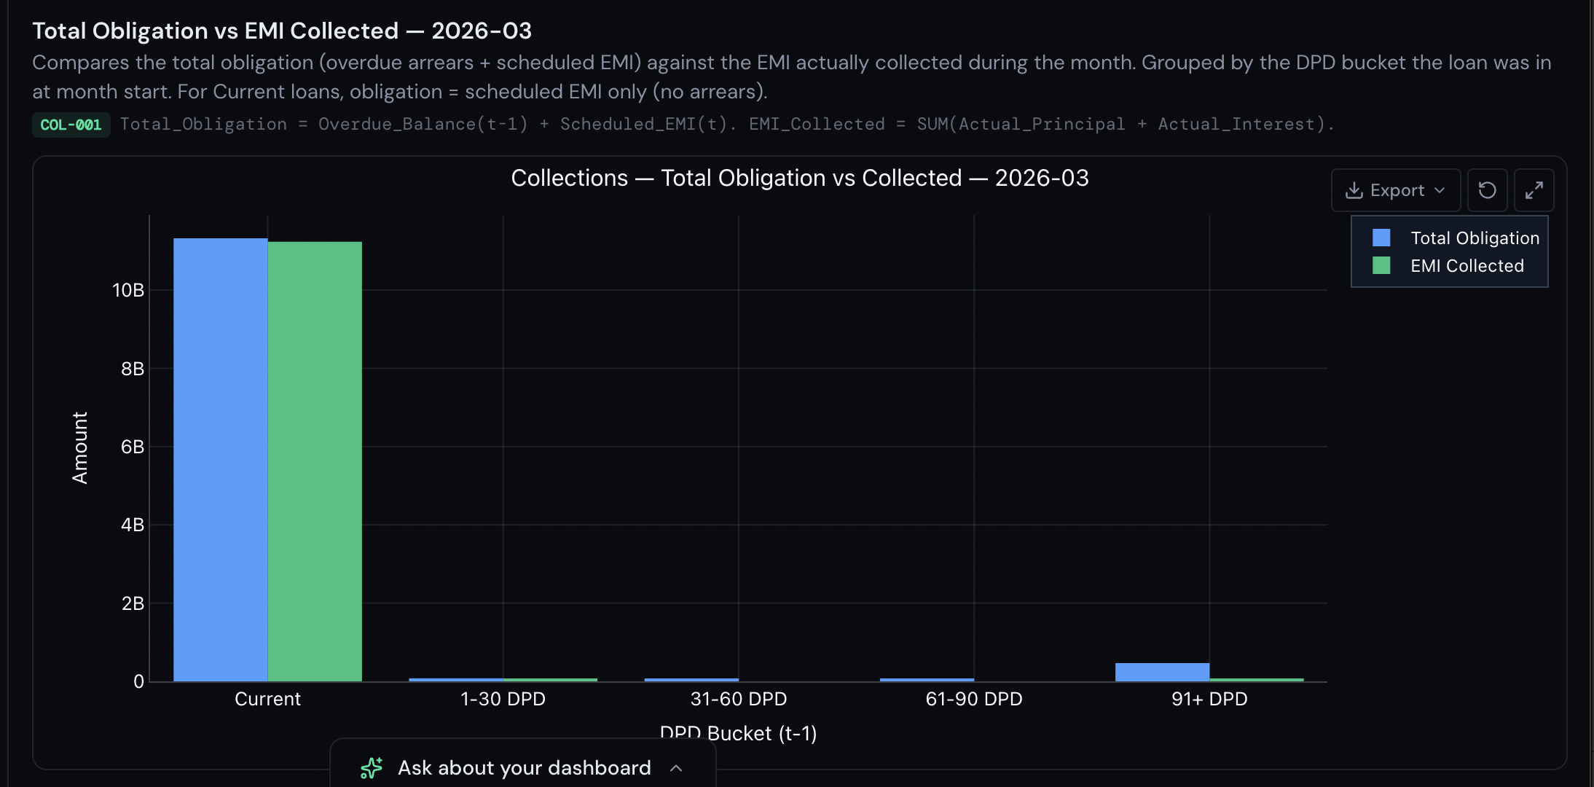
Metric 5 POS Transition Matrix (INR Amount)
Description
An N x N matrix showing the migration of Principal Outstanding (in INR) between DPD buckets across a user-defined time window. N = 5 (the five standard DPD buckets).
Matrix Definition
Cell [i, j] contains the total POS (INR) that was in bucket i at the start of the selected window and in bucket j at the end of the selected window.
Time Window Controls
- Monthly: User selects a specific month. Start state = prior month-end DPD. End state = selected month-end DPD.
- Quarterly: User selects a specific quarter. Start state = last day of the previous quarter. End state = last day of the selected quarter.
- Averaging: User can select a rolling window of N months (e.g., 3 or 6) and the system computes the simple average of the monthly transition matrices across those N months. The averaged values represent average monthly POS flows between buckets.
Visualisation Requirements
- Render as a colour-coded heat-map table.
- Rows = starting DPD bucket. Columns = ending DPD bucket. Row and column headers use the standard bucket labels.
- Cell values: absolute POS in INR Crore.
- Diagonal cells (no movement) = light grey. Above-diagonal (improvement) = green gradient. Below-diagonal (deterioration) = red gradient. Colour intensity proportional to value.
- Row totals and column totals must be shown.
- Include a clearly labelled control panel for: Time Window Type (Monthly / Quarterly), Period Selector, and Averaging Window (single period or N-month average).

Metric 6 POS Transition Matrix (Percentage of POS)
Description
An N x N matrix identical in structure to Metric 5, except that cell [i, j] contains the percentage of POS in bucket i at period-start that migrated to bucket j by period-end.
Formula
Cell [i, j] % = POS flowing from bucket i to bucket j / Total POS in bucket i at start, expressed as a percentage. Each row must sum to 100%.
Time Window Controls
Identical to Metric 5: Monthly, Quarterly, and N-Month Average.
Visualisation Requirements
- Render as a colour-coded heat-map table with the same directional colour scheme as Metric 5.
- Cell values: percentages rounded to one decimal place. Rows must sum to 100%.
- The same control panel used for Metric 5 should drive this matrix (linked controls or adjacent tabs).
- Diagonal cells show the percentage that remained in the same bucket (Stabilisation Rate).

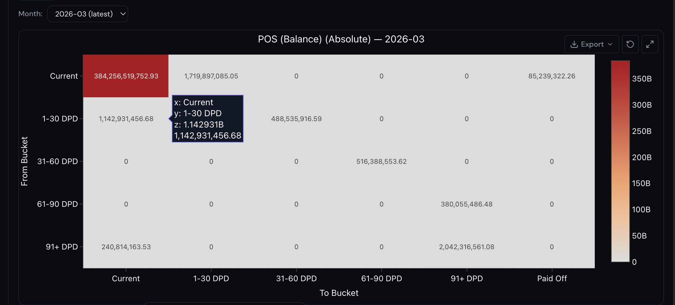
Metric 7 Loan Count Transition Matrix (Absolute Count)
Description
An N x N matrix showing the migration of Loan Count between DPD buckets across a user-defined time window.
Matrix Definition
Cell [i, j] contains the number of loans that were in bucket i at period-start and in bucket j at period-end.
Time Window Controls
Identical to Metrics 5 and 6: Monthly, Quarterly, and N-Month Average.
Visualisation Requirements
- Render as a colour-coded heat-map table using the same directional colour scheme as Metrics 5 and 6.
- Cell values: integer loan counts (or averaged counts for the N-month average mode, rounded to one decimal place).
- Row totals and column totals must be shown.
- The control panel is shared with Metrics 5 and 6 (linked controls).
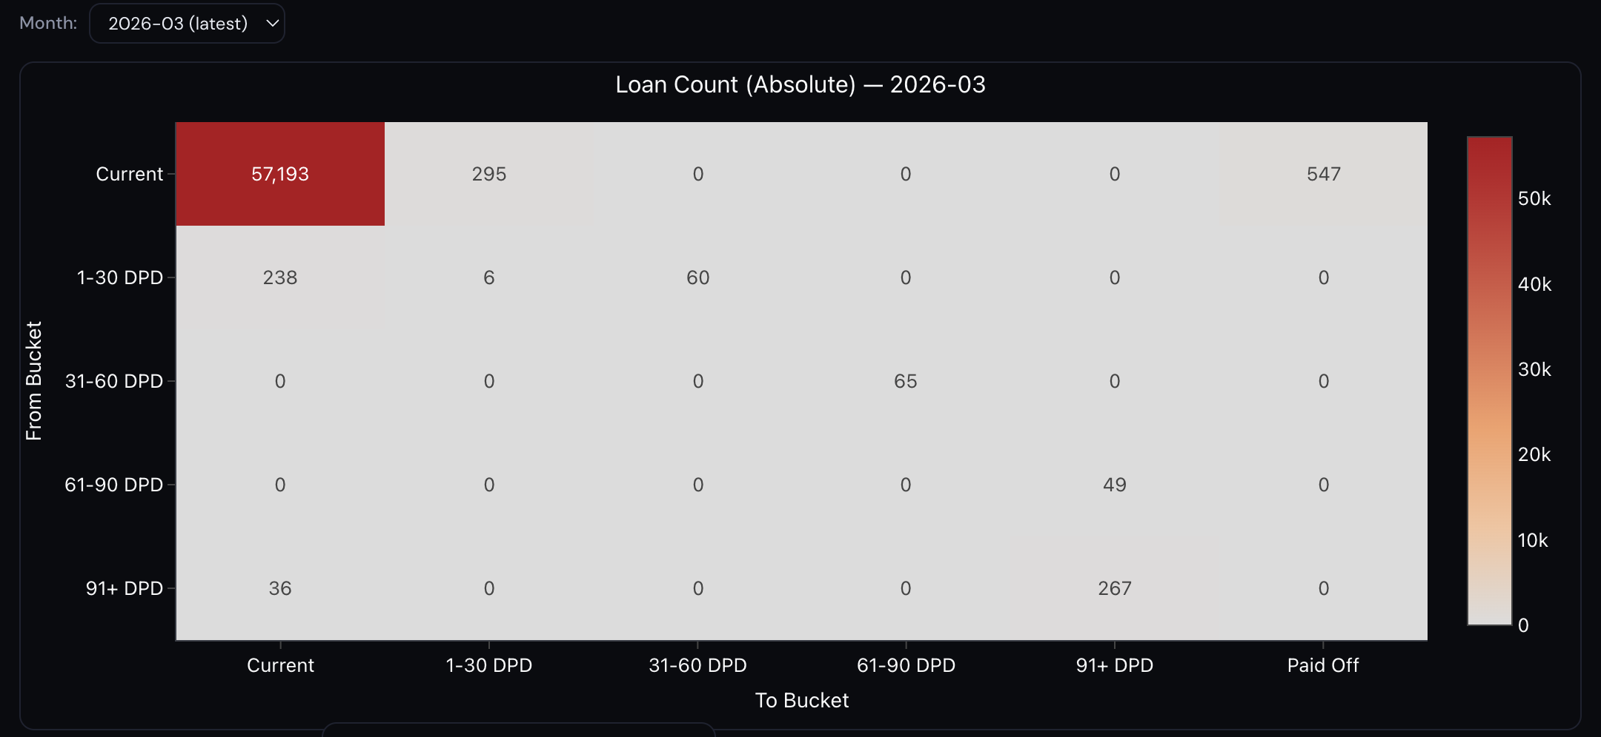
Metric 8 Loan Count Transition Matrix (Percentage of Loan Count)
Description
An N x N matrix identical in structure to Metric 7, except that cell [i, j] contains the percentage of loan count in bucket i at period-start that migrated to bucket j by period-end.
Formula
Cell [i, j] % = Count flowing from bucket i to bucket j / Total count in bucket i at start, expressed as a percentage. Each row must sum to 100%.
Time Window Controls
Identical to Metrics 5, 6, and 7.
Visualisation Requirements
- Render as a colour-coded heat-map table.
- Cell values: percentages rounded to one decimal place. Rows must sum to 100%.
- Linked control panel with Metrics 5, 6, and 7.
Note: Metrics 5, 6, 7, and 8 should be presented as four tabs within a single Transition Matrix panel. The time window control panel applies to all four tabs simultaneously.
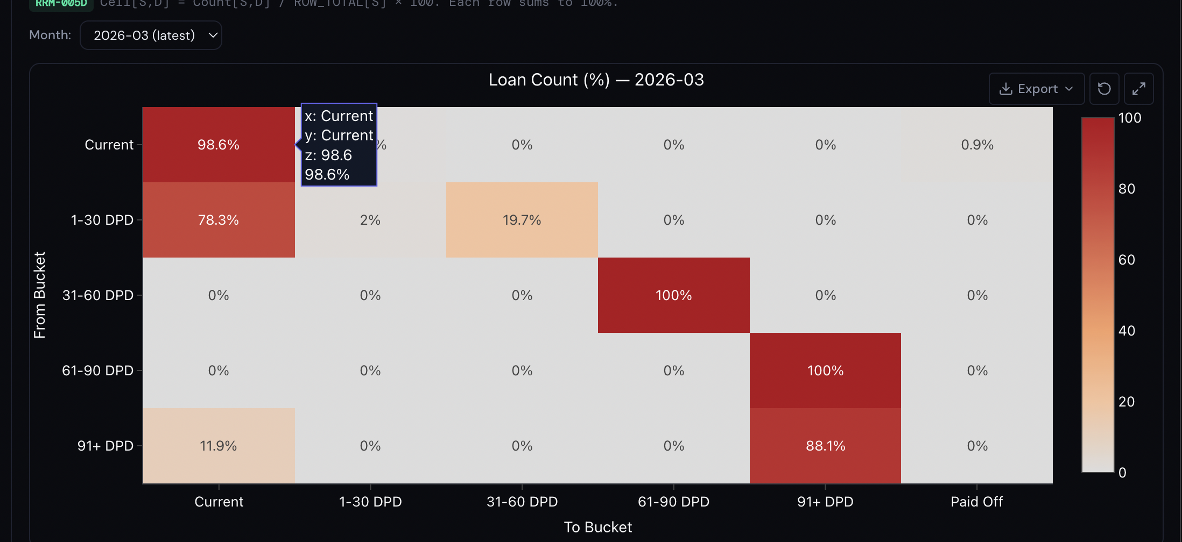

Metric 9 Principal Repayment Rate by Cohort
Description
A line chart showing, for each disbursement cohort, the cumulative principal collected as a percentage of total disbursed principal, plotted against Month on Book (MOB).
Formula
Repayment Rate (Cohort c, MOB m) = Cumulative Principal Collected from cohort c up to MOB m / Total Disbursed Principal of cohort c, expressed as a percentage.
Visualisation Requirements
- Chart type: Multi-line chart.
- X-axis: Month on Book (MOB 1, 2, 3 ... up to the maximum MOB available in the data).
- Y-axis: Cumulative Principal Repayment Rate (%).
- One line per cohort. A cohort selector (multi-select dropdown or toggle) must allow the user to choose which cohorts to display.
- Each line must be clearly distinguished by colour and must include the cohort label (e.g., Apr-2023) in a legend or as a direct annotation.
- Add a target repayment curve as a dashed reference line if the amortisation schedule is available in the input data.

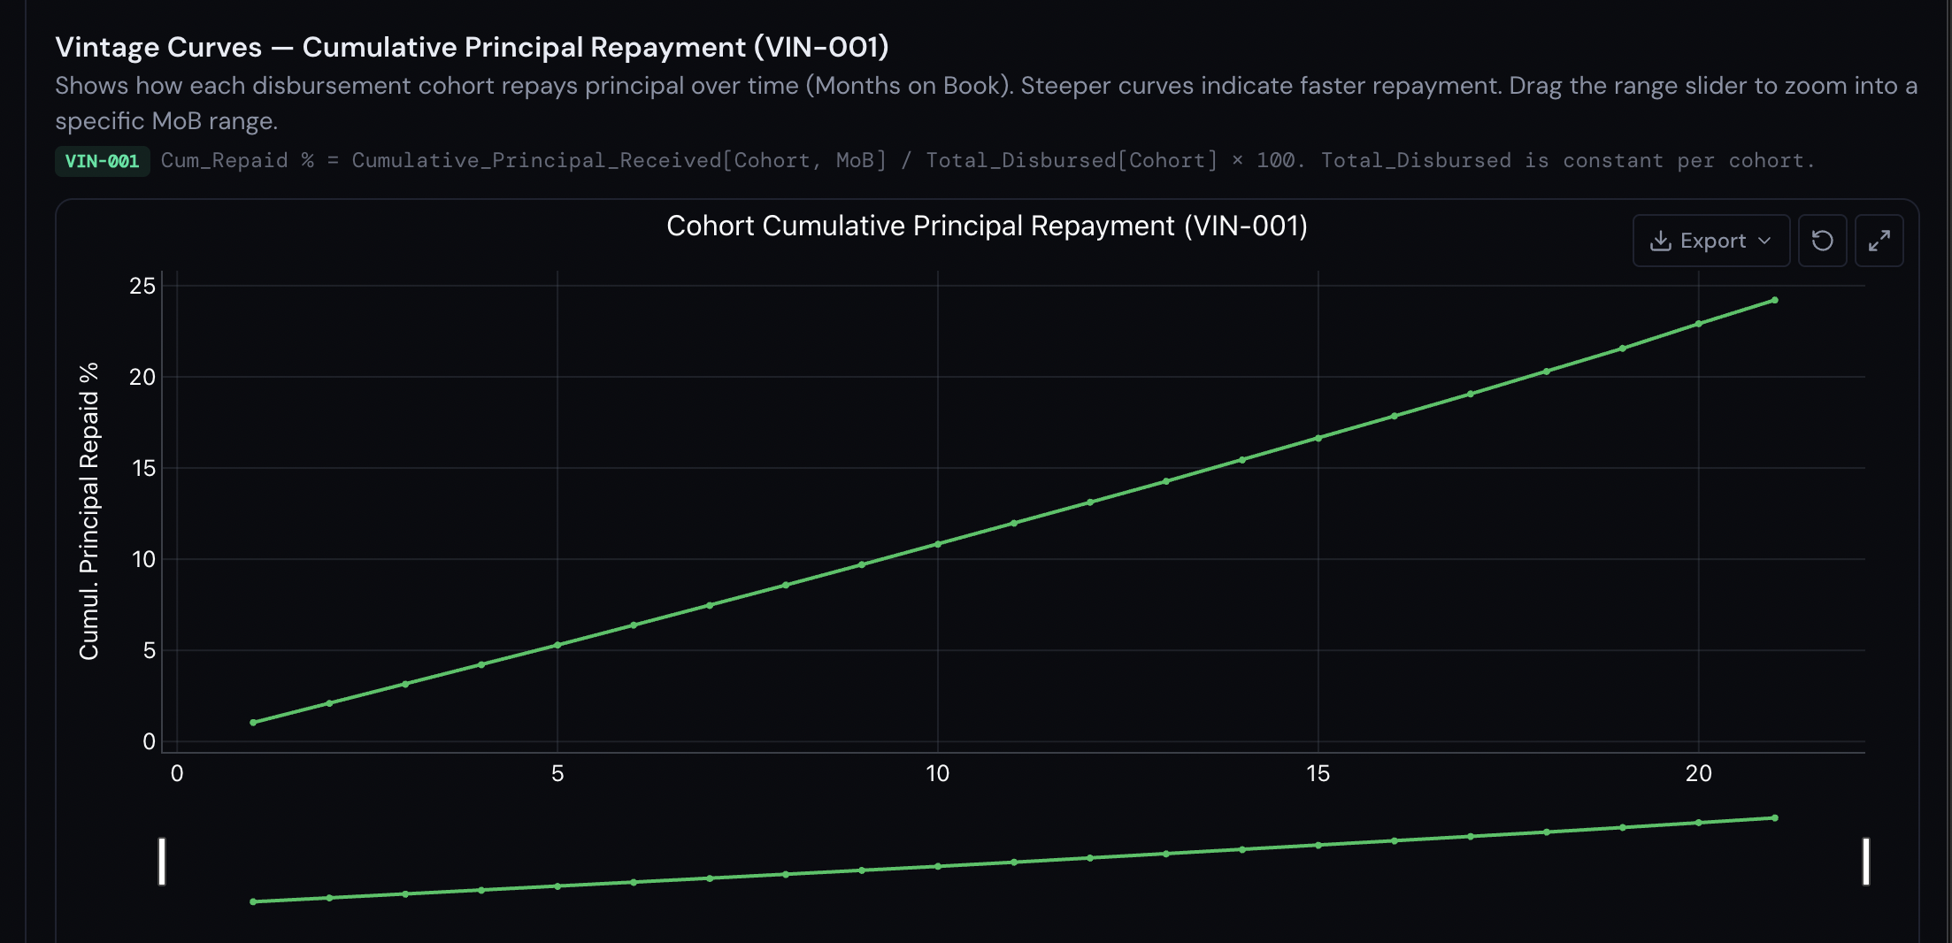

Parse.ai | RMAI Labs Private Limited | Bengaluru, India
This document is confidential and intended solely for candidates in Parse.ai's hiring process.

